

Tickerboxx setup, configuration, and troubleshooting

Initial Setup

1. Plug in tickerboxx into USB socket. The unit will display ‘AP’ on the LED display to indicate that it is in access point mode. This means the unit will broadcast a wifi network which you can connect to to configure it.
2. Using a phone/laptop in close proximity to the unit, under wifi settings connect to the ‘TICKERBOXX’ wifi which is broadcast by the unit.

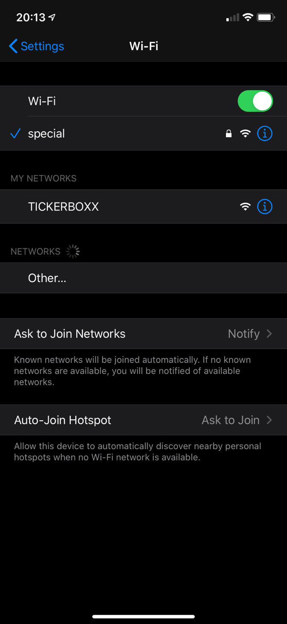

1. Once connected, a web browser will be redirected to ‘tickerboxx.local’ which is the local DNS name of your Tickerboxx unit. If you have more than one Tickerboxx on your network, you will need to configure each separately by browsing to their IP address. (These can usually be obtained by viewing your devices on your wifi router setup pages).
2. Click ‘Wifi Settings’ to take you to the wifi settings configuration page

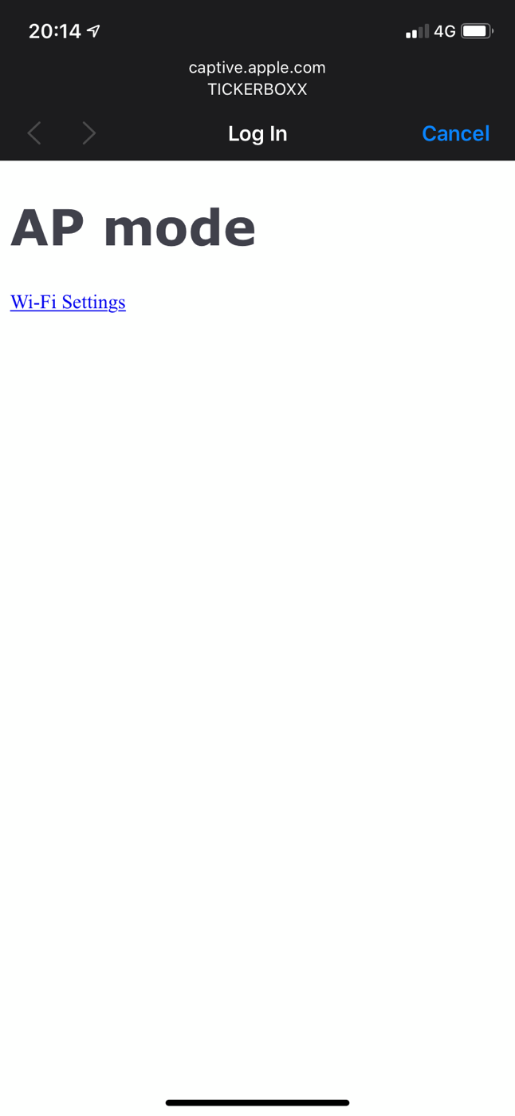

1. Select your wifi ssid and enter your wifi password accordingly. Click submit.

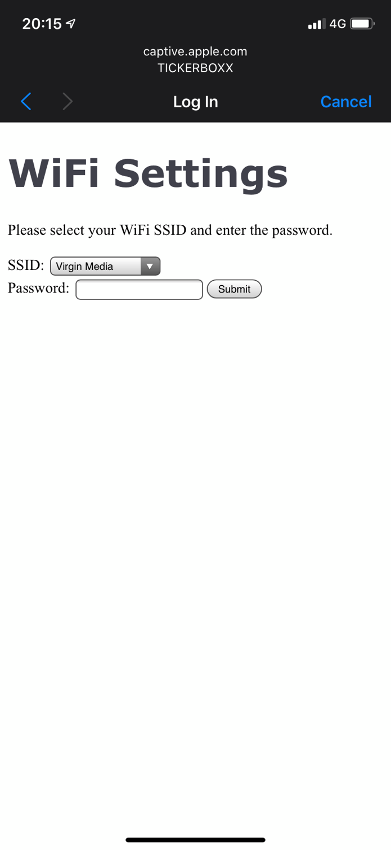

1. If successfully connected to your wifi, the unit will display the BTC price in USD by default, and the following page will be displayed

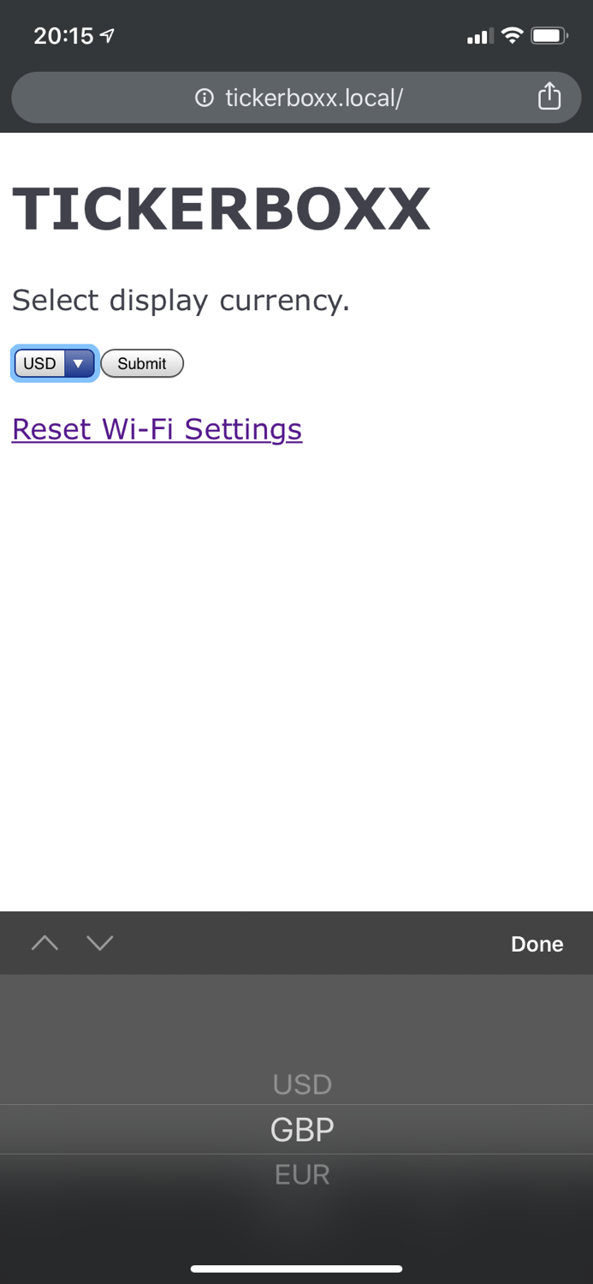

1. Currency settings can be configured using the dropdown and clicking submit.

Currency configuration

1. At any time, using a device on your wifi network, browse to ‘tickerboxx.local’ to take you to the configuration page, where you can select currency or reset your wifi settings to choose an alternative wifi as required.

Troubleshooting:

Unit has been configured but is now displaying ‘AP’ rather than the price.

This indicates that the unit can no longer connect to your wifi. Please bring your unit closer to your wifi router, unplug the unit and plug it back in to attempt to reconnect.

Price is not updating.

The unit requests a fresh price every 10 seconds from the Tickerboxx.com apis, which in turn check for new pricing data from Coindesk every 30 seconds. If the price has not changed to match <https://www.coindesk.com/price/bitcoin> after 2 minutes, or if coindesk also appears to not be updating, then please contact [support@tickerboxx.com](mailto:support@tickerboxx.com).

Unit does not list any wifi SSIDs in the configuration page.

This indicates that the unit is not in range of any Wifi networks. Please bring the unit closer to your wifi router, unplug the unit and plug it back in to attempt to reconnect.

Sent from my iPhone